1. List the user commands and redirect the output to /tmp/commands.list

🡪 ls /usr/bin >> /tmp/commands.list

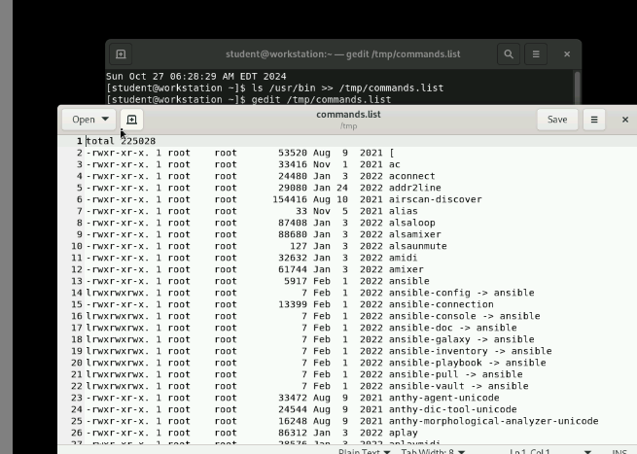

2. Count the number of user commands

🡪 wc /tmp/commands.list



3. Get all the users names whose first character in their login is ‘g’.

🡪grep ^g /etc/passwd | cut -d : -f1



4. Get the logins name and full names (comment) of logins starts with “g”.

🡪 grep ^g /etc/passwd | cut -d : -f1,5



5. Save the output of the last command sorted by their full names in a file.

🡪grep ^g /etc/passwd | cut –d: f1,5 |sort –t: -k2 > naming

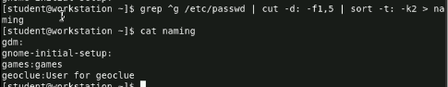

6. Write two commands: first: to search for all files on the system that named .bash_profile. Second: sorts the output of ls command on / recursively, Saving their output and error in 2 different files and sending them to the background.

🡪find / -name bash_profile >> res 2> error.txt

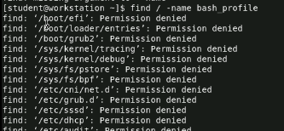

🡪ls –R / | sort > A1

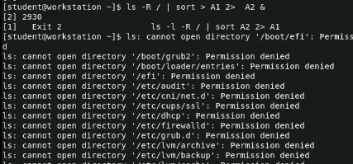

7. Display the number of users who is logged now to the system.

🡪 who | wc –l

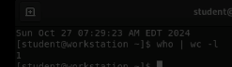

8. Display lines 7 to line 10 of /etc/passwd file

🡪head –n10 /etc/passwd | tail –n4

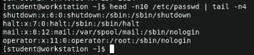

9. What happens if you execute:

• cat filename1 | cat filename2 🡪 output their combined content together

• ls | rm 🡪 error

• ls /etc/passwd | wc –l 🡪 it outputs 1 as it has one line

10. Issue the command sleep 100.

🡪sleep 100



11. Stop the last command.

🡪 ctrl + c



12. Resume the last command in the background

🡪 bg %job_id

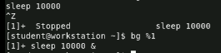

13. Issue the jobs command and see its output.

🡪 jobs



14. Send the sleep command to the foreground and send it again to the background.

🡪fg %job_id , bg %job_id

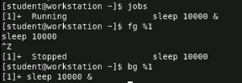

15. Kill the sleep command.

🡪 kill %job_id



16. Display your processes only

🡪ps –fu student

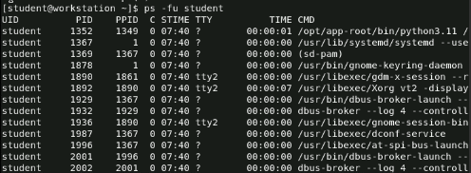

17. Display all processes except yours

🡪ps –fe | grep –v^student

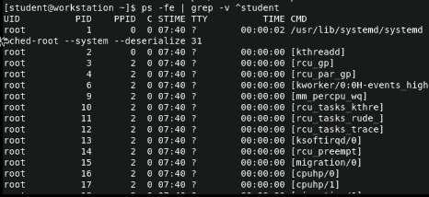

18. Use the pgrep command to list your processes only

🡪pgrep -u student

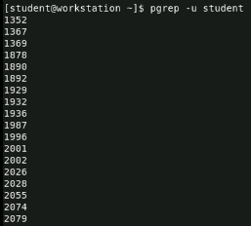

19. Kill your processes only.

🡪 pkill –u student